|  |
| --- |
|  |
| **SQL ASSIGNMENT** |
| **NIMET KAPAN** |
| SUBMITTED TO |
| **MR. HASSAN MAHMUD** |
| **12/1/2023** |

|  |
| --- |
|  |

**SQL Assignment:**

**Database:**

The data set is available as a set of three tables:

* country: Information about countries of the world.
* city: Information about some of the cities in those countries.
* countrylanguage: Languages spoken in each country.

**SQL Server:**

* Create a database named 'world' in your SQL server and select it.
* Execute the scripts from 'worldDbMySQL.txt' to create the tables and populate the data.

**mySql:**

* Run the script (worlddbSQLServer.txt) to create the database and data.

**Tasks:**

1. Produce schema diagram.
2. Using count, get the number of cities in the USA
3. Find out what the population and average life expectancy for people in Argentina (ARG) is
4. Using ORDER BY, LIMIT, what country has the highest life expectancy?
5. Select 25 cities around the world that start with the letter 'F' in a single SQL query.
6. Create a SQL statement to display columns Id, Name, Population from the city table and limit results to first 10 rows only.
7. Create a SQL statement to find only those cities from city table whose population is larger than 2000000.
8. Create a SQL statement to find all city names from city table whose name begins with “Be” prefix.
9. Create a SQL statement to find only those cities from city table whose population is between 500000-1000000.
10. Using LEFT JOIN, ON, what is the capital of Spain (ESP)?
11. Using LEFT JOIN, ON, list all the languages spoken in the 'Southeast Asia' region
12. Create a SQL statement to find a city with the lowest population in the city table.

Create a Word file that addresses all the questions above. Include screenshots of

the code along with their corresponding answers.

**ANSWERS**

I took those steps to create database, tables and insert data into tables:

1. Create Database named ‘world’



2. Use ‘world’ as active database



3. Create tables, which are city, country and countrylanguage, by copying the

scripts from Assignment.

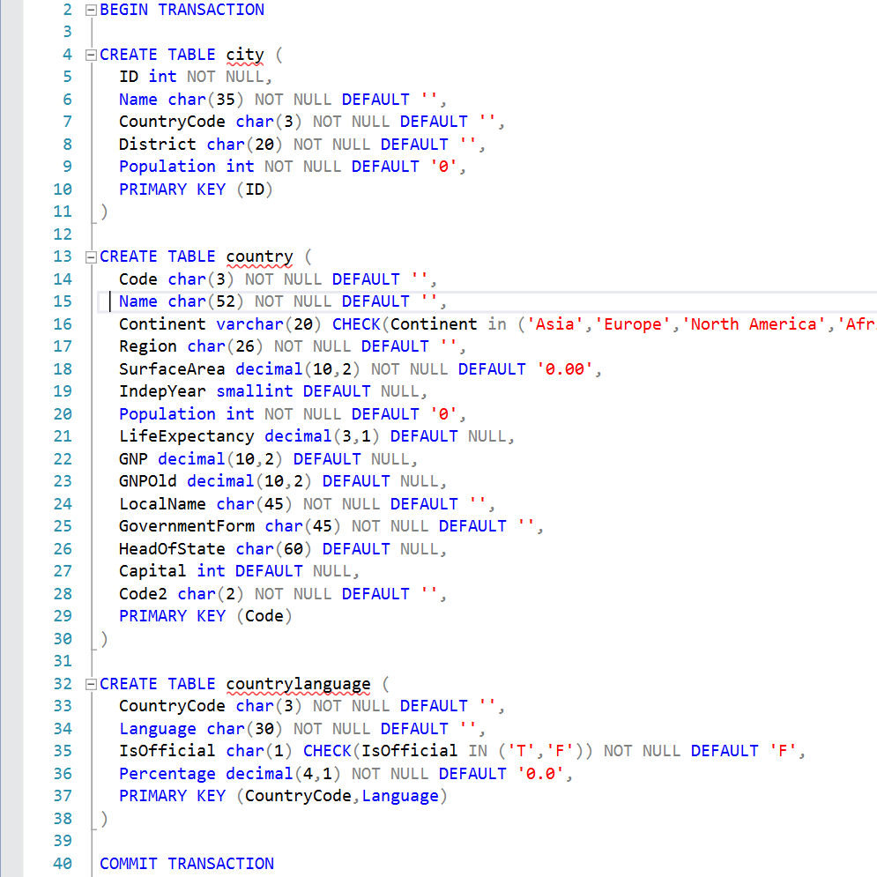

After creating table and refreshing the “world” database , tables shown as below;

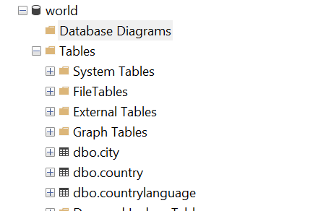

4. Insert Data into table by copying the scripts from Assignment.

**TASKS**

**1)** Produce schema diagram

Relationship between tables:

A country can speak many languages (1-N) or a language can be spoken by many countries (1-N) . As a result, relationship between country and languages can be (N-N). But there are two primary keys for “countrylanguage” table which are Country code and Language. Together they form a unique identifier for each record in the table.

As a result;

A country has many cities (1-N)

A country can speak many languages (1-N)

Schema diagram is given below:

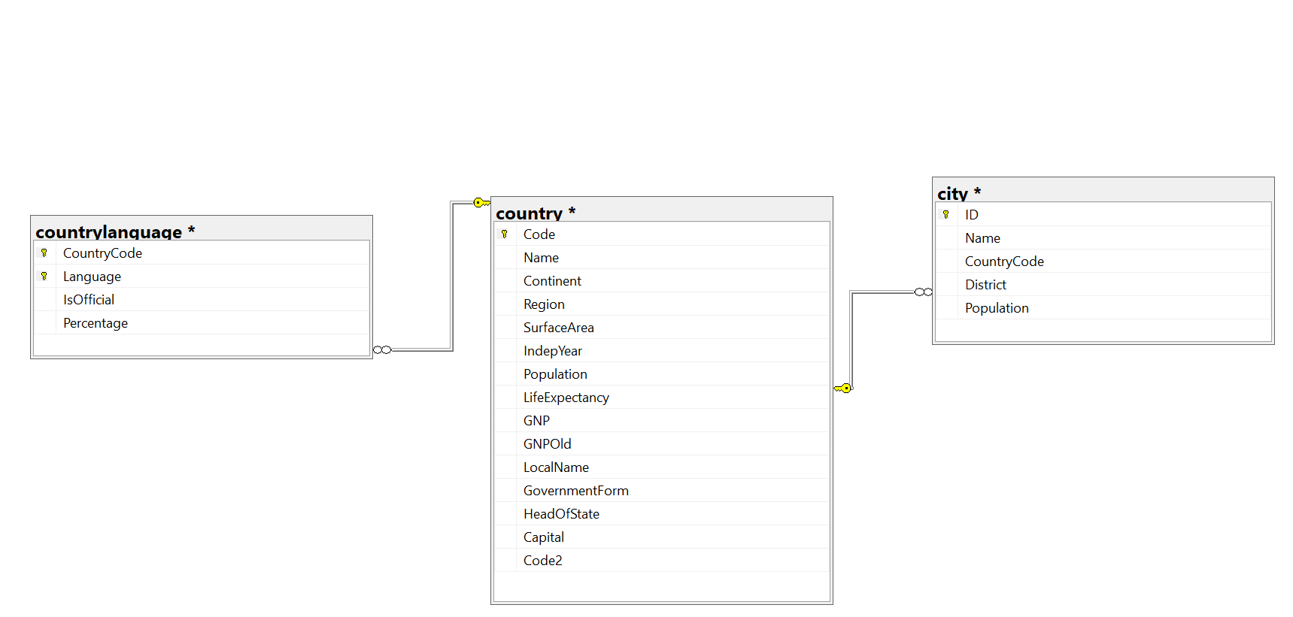

2) Using count, get the number of cities in the USA

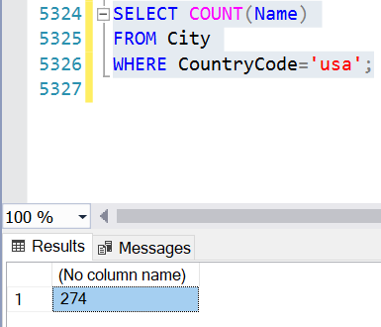

Or I can add the column name as below:

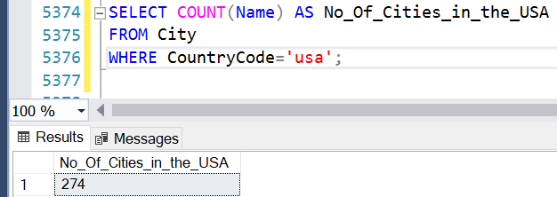

3) Find out what the population and average life expectancy for people in Argentina (ARG) is

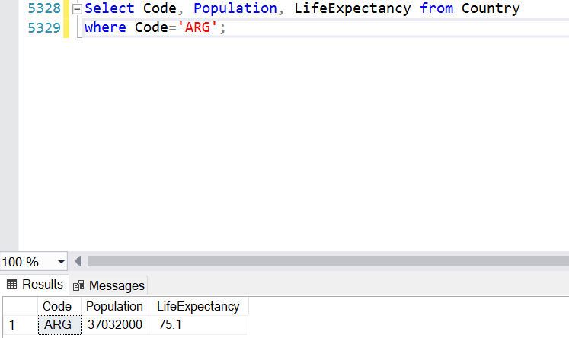

4) Using ORDER BY, LIMIT, what country has the highest life expectancy?

I used ‘ORDER BY column_name DESC’ .

ORDER By , by default gives ASC order, so you don’t need to write it. But for DESC order, you need to write DESC with ORDER BY.

‘Andora’ has highest life expectancy with 83.5

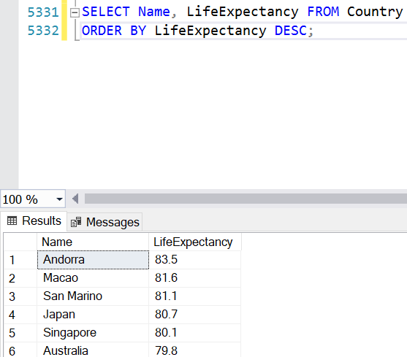

When I use LIMIT 1 to see only 1 row, it gives error as below:

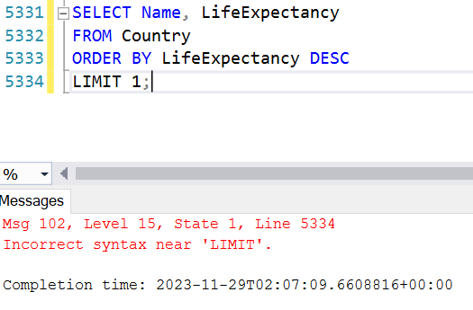

I used ‘TOP’ command instead of ‘LIMIT’ see below:

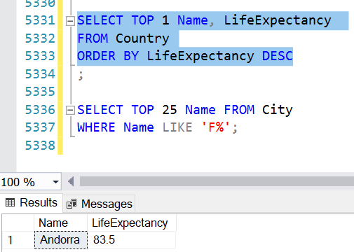

Then I only got the result of the country with highest life expectancy which is Andora.

5) Select 25 cities around the world that start with the letter 'F' in a single SQL query.

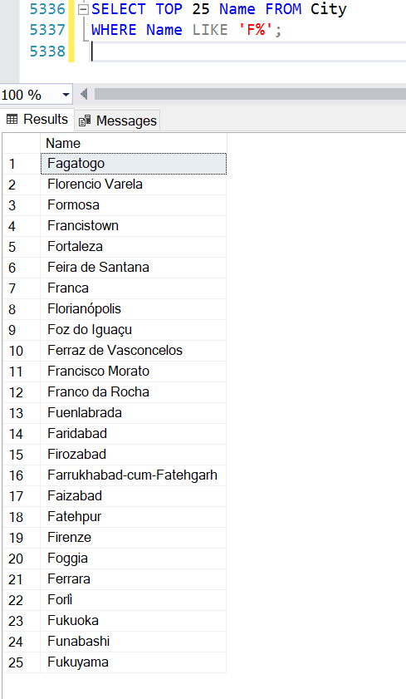

6) Create a SQL statement to display columns Id, Name, Population from the city table and limit results to first 10 rows only.

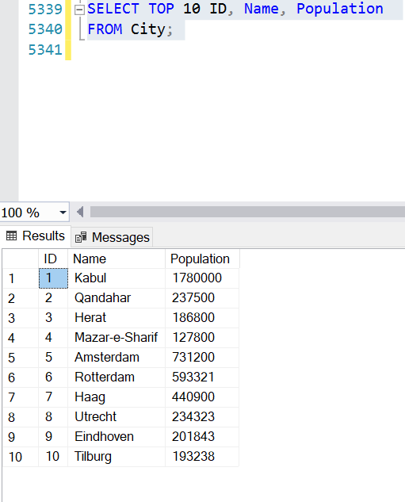

7) Create a SQL statement to find only those cities from city table whose population is larger than 2000000.

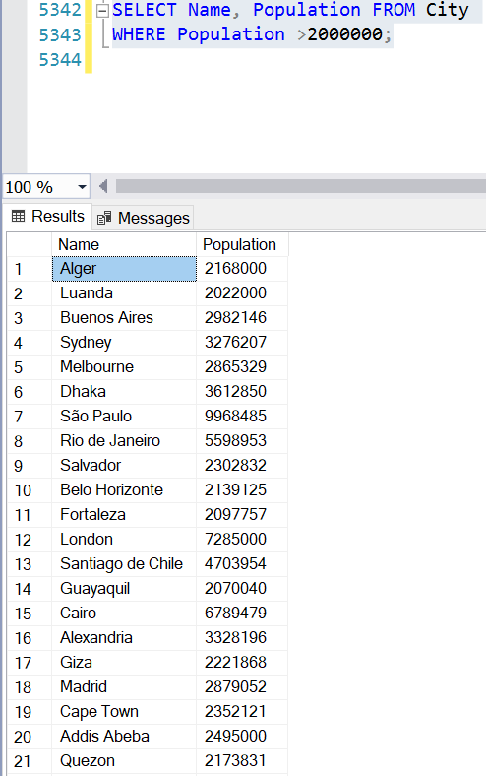

8) Create a SQL statement to find all city names from city table whose name begins with “Be” prefix.

It showed 49 city names that start with “Be” prefix

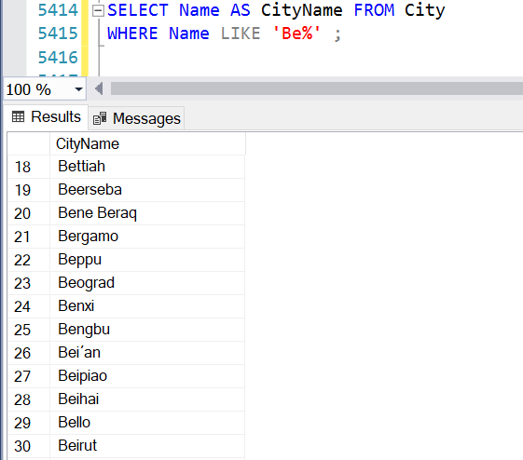

9) Create a SQL statement to find only those cities from city table whose population is between 500000-1000000.

Below statement gives the population by order,

Start with 500000 which is Pointe-Noire and last with 1000000 which is Amman

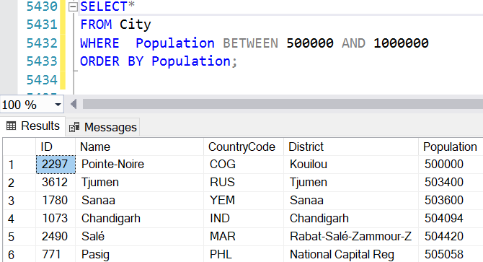

Or result only can include City Name and Population as below;

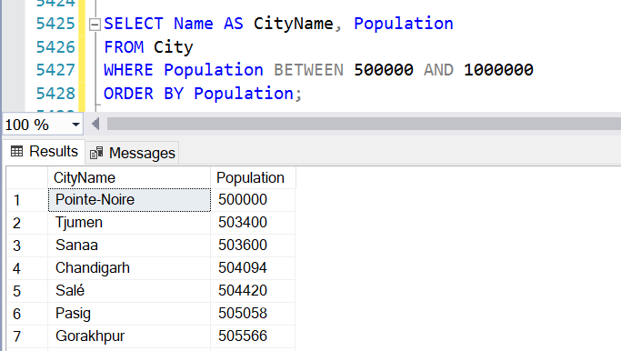

10) Using LEFT JOIN, ON, what is the capital of Spain (ESP)?

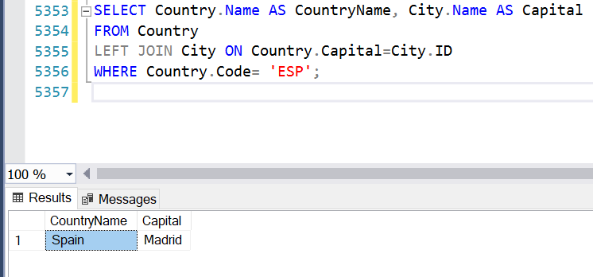

11) Using LEFT JOIN, ON, list all the languages spoken in the 'Southeast Asia' region

It is 47 Languages spoken in ‘Southeast Asia’ Region. “Distinct “command eliminates the duplicates.

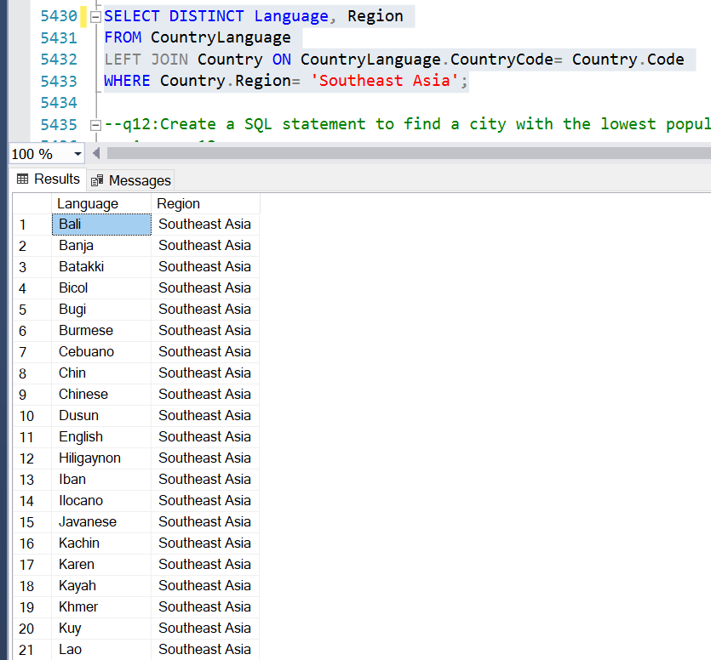

Without “Distinct” command, result is “65” because of the duplication as shown below;

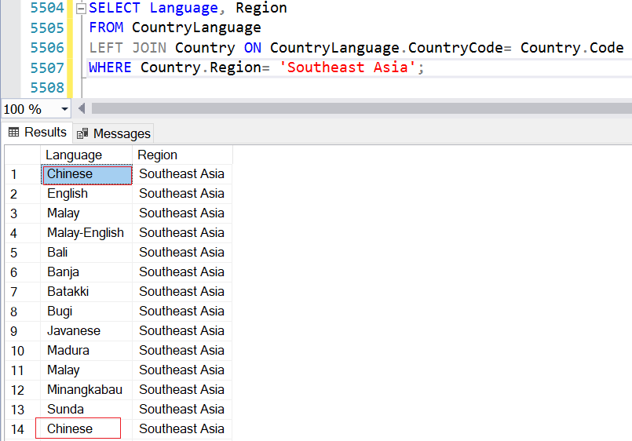

12) Create a SQL statement to find a city with the lowest population in the city table.

The city with the lowest population is Adamstown, with the population of 42.

